Learning from lived experiences training



This document
On April 15th, 2025, we ran a training session in partnership with WeDoCare. This document details the outcomes from that day and a proposal to utilise this learning for future sessions.
I, Kelsey Lentes, have prepared this document to evidence the work completed but also to highlight the need for future sessions like this.
Each section of this document has been broken down into smaller sections for ease of reading, please click next to each subheading on the arrow to see the full text. Some documents are linked throughout so please double click on them to open the external document.

Planning
I attended the Care Ambassadors group on the 26^{th of} March to gather information and feedback from young people with lived experiences about social workers and the system in general.
Disappointingly, but unsurprisingly, most of the feedback was negative, with significant upset and distrust towards social workers as a result of these experiences.
Below are the prompts used to facilitate this discussion.
We are hoping to support our Newly Qualified Social Workers to be as person-centred as possible.
We want this training to help them learn from your experiences with social workers, professionals in general and the system we work in.
I have listed some points below that we would like you to reflect on.
We don’t necessarily need you to tell us about your personal experiences such as why you are in care.
You only need to share what you are comfortable with.
- How old were you when you had your first social worker?

- What were you told about what a social worker does vs what you now know about what a social worker does?

- What do you think about the system in general? Does it work? Are there aspects that help people?

- Tell us about a time you had a good experience with a social worker? (if there isn’t one, are there any professionals who left a good impression?)

- Tell us about a time you had a bad experience with a social worker?

- In your experience what are social workers good at?

- What do you wish social workers knew?

- What would you change about social work?

- What are your top tips for social workers?

- Anything else you want to share about your experience of having a social worker or about the system in general?

The young people spoke freely with me and shared their wealth of knowledge, this information was then converted into the slides (see below). The young people then put their names in a hat to be the trainers as there were so many volunteers.
On the 11^{th of} April we did a practice session with the young people at the venue and made amendments to the slides and structure of the day.
The session took place at the youth space at The Grange School.
The day was planned out of the office to put social workers in a different environment and empower the young people to be in their own space. We also had a number of role-play exercises where the social workers were treated as the young people, and this placed them out of their comfort zone; having to experience the worst of the lived experiences our young people described.
Each Session was run by a different young person, but they were partnered up so that they could help each other and for moral support.
We also included a reflective space at the end of the day with just the social workers to speak and reflect on how they found the day and what they have taken away from it. This has also aided this proposal and helps us to develop future training and make adjustments.

Schedule of the day
Below is the schedule for the how the day ran.
Time | Young People | NQ’s
9:30 | Arrival time and preparation time
9:45 | Arrival time and preparation time | Arrival time and coffee
10:00 | Session 1 – Our experiences
11:00 | Coffee break
11:15 | Session 2 – The good and bad social workers
12:15 | YP debrief and leave | Videos from adults with exploitation experiences
12:30 |  | Videos from adults with exploitation experiences
1:00 |  | Lunch time
1:30 | Arrival time and preparation time | Lunch time
2:00 | Session 3 – Language and labels (role play exercise)
3:00 | Coffee break
3:15 | Session 4 – How you can do better - Pledges
4:15 | YP debrief and leave

Slides
Double click on the slides to view the presentation. You will need to click the three dots and show presenter view to see the notes.
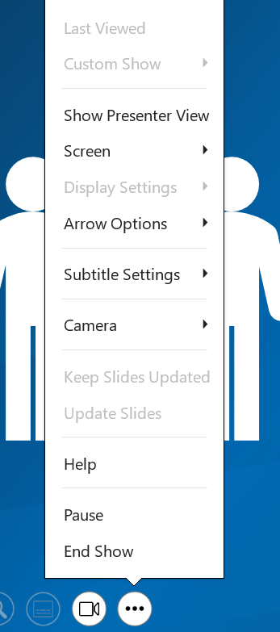

Mr Green and Mrs Pink
Mr Green is the good social worker and Mrs Pink the bad social worker. The things the young people would like to see and what they would not want to experience (respectively).
These posters were created by the young people at care ambassadors and hung on the walls of the training rooms for the social workers to review.

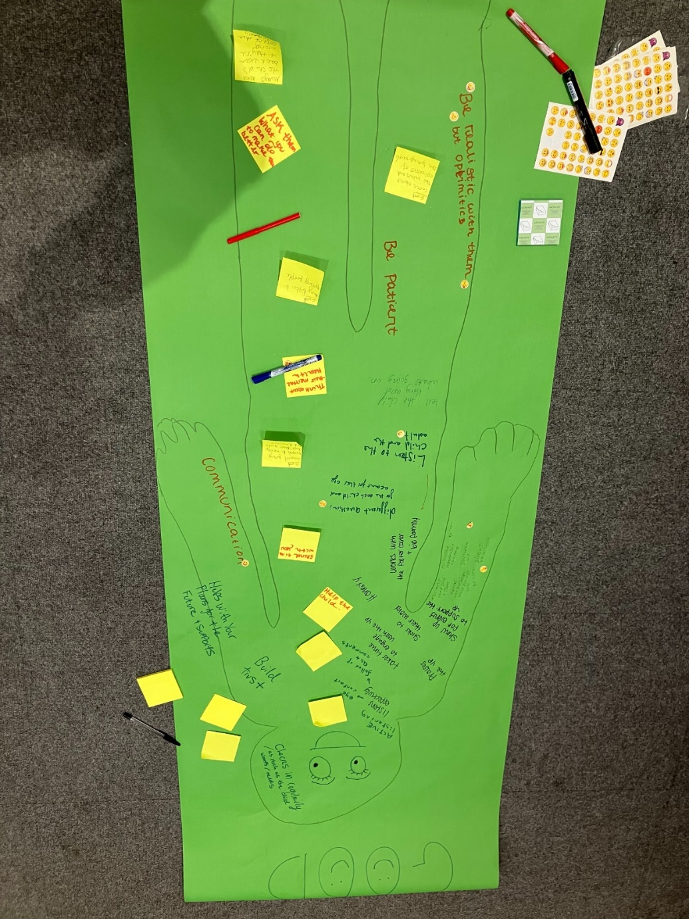

Mr / Mrs Green – The good or aspirational social worker
(Below is the list of what is included on the drawing / poster).
- Checks in regularly – as much as the child wants/ needs.
- Active listening /Listens effectively – eye contact / follows up and comments.
- Praises the young person
- Helps with the young person’s plans for the future and support.
- Build trust.
- Helps the young person.
- Takes the time to engage with the young person.
- Sticks to their word
- Honesty
- Communication
- Shows up for events to support the young person.
- Works with the foster carer and bio family
- Spend time with you.
- The ones that don’t assume
- The ones who don’t sneak behind the child’s back.
- Different questions for each child and account for their age
- Listen to the child and adult.
- Support young people to accomplish their goals and dreams.
- Think about their mental health.
- They listen to young people.
- Cares about the views and opinions of the young people
- Always have the child’s back even when they are wrong, correct them privately
- Ask them what you can do to make things better.
- Be realistic with them but optimistic.
- Tell the child things and what’s going on.

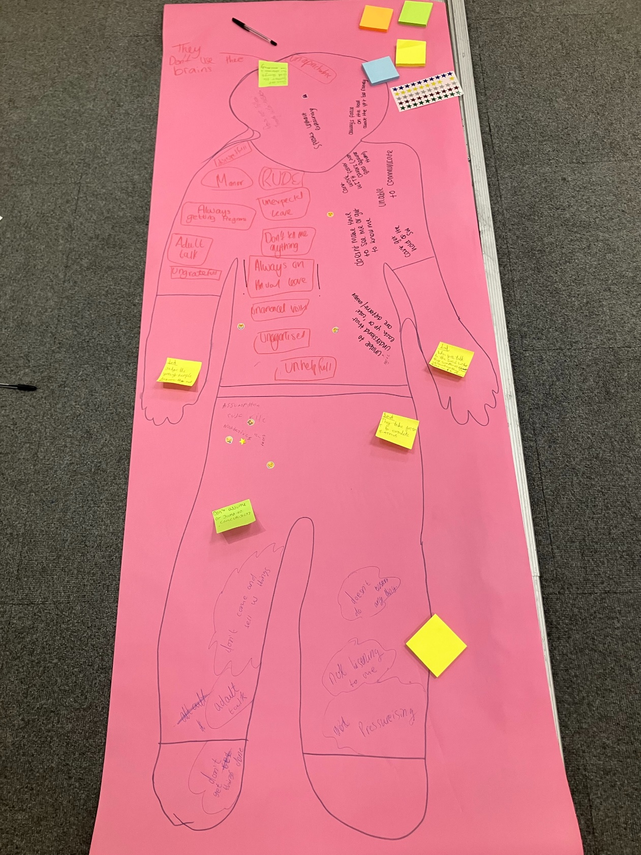

Mr / Mrs Pink – The bad social worker
(Below is the list of what is included on the drawing / poster).
- They don’t use their brains.
- Unapproachable
- Always focus on the bad about the young person or bio family
- Rude
- Maners
- Unexpectedly leave.
- Disrespectful
- Always getting pregnant
- Adult talk
- Ungrateful
- Always on annual leave
- Unannounced visits
- Unorganised
- Unhelpful
- They take forever to complete forms.
- Doesn’t do anything.
- Don’t come and tell us things.
- Can’t get hold of the social worker.
- Unable to communicate.
- Doesn’t make time to see me or get to know me.
- Unable to understand each young person or “case” is different.
- Speaks without explaining.
- Not listening to me
- Pressurising
- Assumes or jumps to conclusions.
- Not believing

Label list
During session three the social workers take part in a role play exercise. The young people moved around the room with clipboards and ask some ice breaker questions to get to know the social workers, this lasts for ten minutes and there has been no explanation to the social workers about what is happening, mirroring the feedback received that often young people are on the back foot about meetings and agendas.
The young people then label each of the social workers with a number of different labels, some positive, some negative and some indifferent.
All of these words have been used to describe the young people either directly to them or in reports written about them.
- Sweet
- Supportive
- Kind
- Caring
- Nice
- Thoughtful
- Polite
- Brave
- Inspiring
- Resilient
- Delightful
- Creative

- Red Kid
- Argumentative
- Challenging
- Aggressive
- Violent
- Attention-seeking
- Emotionally withdrawn
- Misbehaving
- Disengaged
- Disruptive
- Annoying
- Hard to reach

After this everyone is separated into groups bad and good people based solely on these labels, we were then asked to reflect on how we found this process and how we felt about being labelled after they didn’t know us very well.

Pledges
Please double click on the below image and it will open a PDF that includes the pledges made by the social workers in Session 4 about doing better.

Videos

Below are two videos on YouTube where adults discuss their experiences around exploitation and the systems in general. These should not be played while the young people are present as they contain graphic descriptions.
A warning should be provided prior to playing this video around the content and a brief discussion held afterwards to ensure that everyone is okay.
From Dealing Drugs in School to Tackling Youth Crime | DEEP (youtube.com)
Arrested With Firearms At 17 | Deep - YouTube

Feedback
Both the social workers and the young people were asked for feedback about how the day ran. Some of this information was collected using Microsoft forms and other was verbal feedback provided on the day.

On the question – What three words would you use to describe the day?
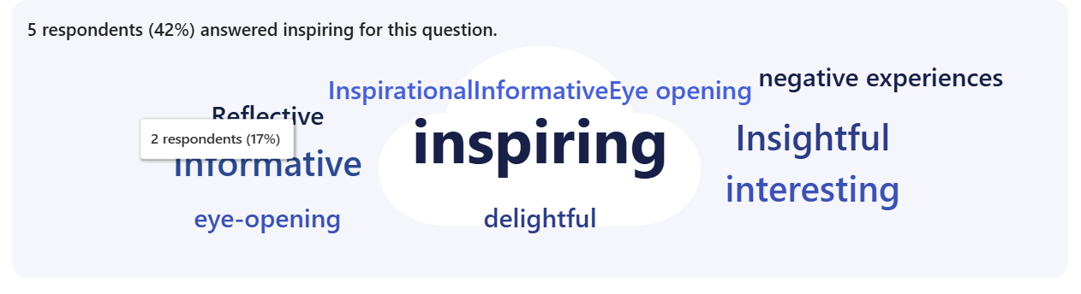
On the statement – I would recommend this training to others – 100% of respondents said 10/10 – definitely.
On the overall rating of the day, twelve social workers and two young people gave it 5 out of 5 stars.
The social workers told us-
“The day was well thought out and well structured, and the young people who led sessions were inspiring. I intend to keep coming back to their voices so that I can (hopefully) create a more supportive environment for the young people I work.”
“The day offered valuable insight and served as an important reminder of our role and purpose, to support the children for whom the state has assumed a parental responsibility, and to work towards keeping families together wherever it is safe to do so. It highlighted the importance of ensuring that families do not perceive social workers, who are employed by the state, as oppressive and intrusive. The term "wrecking ball", used by the children to describe their experience of social work intervention is powerful and deeply reflective. it challenges us to approach our work with empathy, sensitivity and focus on building trust, so our involvement is supportive not destructive.”
“Really well planned and thought out day. It felt really empowering that the young people were supported to facilitate the day and voice their experiences.”
“
The young people were so honest and open and were very articulate in getting their views across. A pleasure to meet such lovely young people.”

The young people told us-
“This was the best thing ever. Because we are constantly complaining about social workers and now we get to make the difference. And help those in the future. This has really helped care ambassadors to show that we don't just sit and talk we take action as well.”
The young people were also asked if they felt listened to, respected and enjoyed themselves and they responded 100% definitely to all three questions.
Crucially the young people were also asked whether they felt that our training day accurately portrayed what had been shared at Care Ambassadors and they all said yes.

Proposal
The feedback from the young people, participation team and the social workers is that this would be beneficial to be rolled out much wider than just the Newly Qualified Social Workers and that it should form part of the training offer for all social workers.
We have a number of young people who are very keen to be involved in the session and a number of ways to develop and expand the training. It would require funding in order to ensure our young people are paid for their time, but I believe its money well spent.
A realistic plan would be to run the training three times a year: during the Easter holidays, summer holidays, and October half-term.
This would allow our young people to be involved without missing education and to not make this too demanding so that it interferes with other work that the Care Ambassadors do.
The running of the day requires at a minimum one member of staff to co-ordinate the day (i.e. me) and one member of staff to support the young people (this was Angel from the participation team).

Costings
Each young person works half a day for which we pay them in a £25 one4all voucher. This is due to requirements on hours they can work and enables the social workers to hear from a number of different young people with different experiences.
Two young people work in the morning and two in the afternoon.
£25 x 4 young people = £100 per day
£100 x Three training sessions per year = £300 total cost
Each training session could support a maximum of 15 practitioners meaning that across the year we could support 45 social workers to gain a better understanding of the lived experiences of our young people.
It would also mean that 12 young people per year have an opportunity to have their voices heard and shape social work practice.

